**Analysis of growth of specific strategy in the pool of strategies**

**KomalGujarathi1, Snehal More1**

1 TE COMP, Cummins College Of Engineering, Karve Nagar, Pune 411052, India .

**Abstract:**In this paper we analyze different strategies for their response against other strategies using the Iterated Prisoner's Dilemma. It describes the study made for analyzing the relative population growth of each representative strategy and also talks about the mathematical model and itsimplementation developed for the above study. Our experiment of placing different strategies in a pool and allow them to evolve in coming generations will show results of applying Charles Darwin’s principle of “Natural selection” to these strategies.

Based on the results obtained from this study, the paper will discuss results in context of human interactions regarding cooperative behavior. This study can help us find out whether there is any hope for cooperative nature to increase in coming generations in the presence of other strategies like ‘Cheater (who will always cheat others)”. The paper will crosscheck the commonly believed (Common man’s) hypothesis “Cooperation and honesty is decreasing over generations”.

**Keywords:** Prisoners dilemma, Iterated Prisoners dilemma, Pay off matrix, evolution.

**INTRODUCTION:**

Individuals in the society have to interact with other individuals to grow in society. These individuals in a group behave in different ways, and their characteristic behavior can be represented broadly with two kinds of responses namely Co-operate (trusting and co-operatingwith others) and Defect (non-trusting and defecting with others). This paper creates a virtual society and captures interactions between them. Each individual follows different strategies to arrive at the decision of co-operate(referred as’C’) v/s defect(referred as ‘D’in the following text). To study these interactions and their effects over the generations we apply Iterated Prisoners Dilemma(IPD).

**MATERIALS AND METHODS:**

This paper derives its motivation from the competition conducted by a political scientist Robert Axelrod who pioneered research in this field in the late1970’s. Axelrod used the Prisoner's Dilemmatorepresent his studies. As part of this research Axelrod held a series of computertournaments in which IPD strategy entries from around the world played games of theIPD against one another in a round robin fashion. This tournament aimed to identifyoptimal strategies for the Prisoner's Dilemma (there is no *best* strategy; the success ofa strategy depends on the other strategies present). The Tit For Tat strategy (TFT)won both computer tournaments conducted by Axelrod indicating that it is an optimalstrategy.

We would like to extend the above concept over multiple generations to study the fate of co-operative nature in the society.

Interactions among individuals in a society is based upon the classic Prisoner's Dilemma (PD). In a PD two prisoners are questioned separately about a crime they committed. Each may give evidence against the other or may say nothing. If both say nothing, they get a minor reprimand and go free because of lack of evidence. If one gives evidence and the other saynothing, the first goes free and the second is severely punished. If both give evidence, both are severely punished. The overall best strategy is for both to say nothing. However not knowing (or trusting) what the other will do, each prisoner's best strategy is to give evidence, which is the worst possible overall outcome.

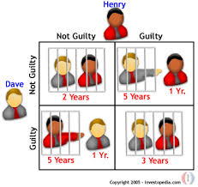

By applying PD to our concept of strategies we use following pay off matrix.

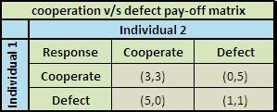

In our simulation of interactions between different strategies, each strategy will have interaction with other strategy and decide to either co-operate or defect. In this interaction both the participant strategies will obtain the points according the above pay off matrix. Each strategy will have its decision making algorithm to arrive at its response.

We restrict our simulation to 3 important and representative strategies namely ‘Co-operator’ (always co-operates), ‘Defector’ (always defects) and ‘Tit for Tat’ (cooperates first time and further cooperates with cooperator and defects with defector).

We apply the variant of PD known as the Iterated Prisoner's Dilemma (IPD) inwhich two participating strategies interact iteratively against each other. This removes the obvious advantage for the defectors and represents the real nature of interactions in the society.

The length of the IPD (i.e. the number of interactions) must not be known to either player, meaning this information cannot be used by individual strategy to arrive at decision. To study the relative response behavior among different strategies we initially create a pool of different populations of each strategy. In one generation, each strategy interacts with other strategy in round robin manner. Through these interactions within one generation each strategy group earns points as per the pay off matrix. The relative proportion of points is taken as the basis to decide the reproduction of each strategy group and it decides the population of each strategy group in the next generation. The same process is repeated for next generations till the relative population comes to a stable state.

We considered representative scenarios to simulate important interactions within scope of our study.

**Invasion of strategy into others:** We considered a dominant group belonging to a same strategy and one invader of other strategy.

Note: Generation on x-axis and population on y-axis.

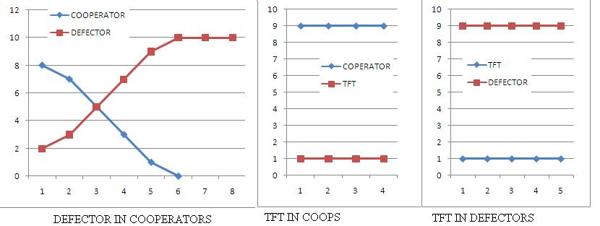

Results show that invasion of defector is fatal to cooperators whereas cannot affect TFT. Invasion of TFT does not affect cooperators but maintains its existence. Invasion of cooperator cannot affect TFT but gets wiped out against defectors.

**A smallgroup of one strategy into other:**We considered initial population having one dominant strategy.

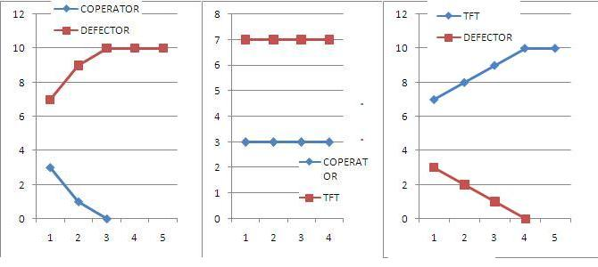

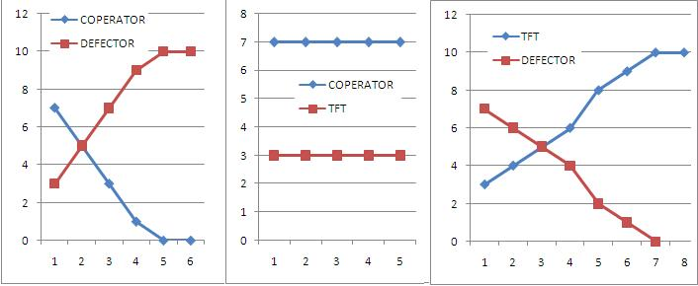

The results of this case shows that interaction of cooperators and defectors remain unchanged whereas if TFT with a minimum mass can dominate over the big population of defectors. This result is very important to demonstrate the strength of Tit for Tat strategy.

**Equal population of all three strategies:**We consideredinitial population of ten individuals of each strategy.

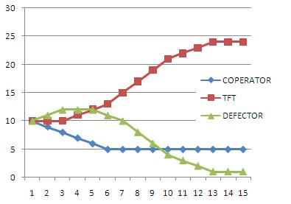

The results show that there is a initial increase in the number of defectors but over the generations the defectors diminish and the cooperators maintain the constant minimum population. The initial increase in defectors is due to lenientand altruistic approach of cooperators. But once the population of cooperators reduced, defectors started starving and the equilibrium was achieved for the cooperators with the support of TFT.

**CONCLUSIONS:** By studying the above results, we arrived at the following conclusions. In a group of only cooperators and defectors, cooperators cannot survive in the presence of defectors. But by just in the presence of few ‘Tit for Tat’s, cooperators are able to survive whereas defectors diminish over the generations.

**LIMITATIONS:**In a real society, practically a person may not always follow the same strategy over the time and in every situation. Hence this initial model simulates the idealized social behavior within the boundaries of isolated three strategies. This simulation can be further made more accurate to represent social behavior.

**STEPS IN SIMULATION:**

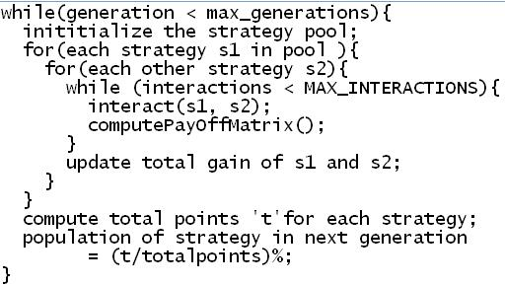

**REFERENCES:**

http://plato.stanford.edu/entries/prisoner-dilemma/

http://en.wikipedia.org/wiki/Prisoner's_dilemma

http://en.wikipedia.org/wiki/Tit_for_tat